mid-test

Mehrab Atighi

12/8/2021

# mid-test-Mehrab Atighi - question 2  
library(MASS)  
noshabe=read.table("C:/Users/Frostless/Desktop/noshabe.txt",header=T)  
head(noshabe)

## y1 y2 x1 x2 x3 x4 x5 x6 x7 x8  
## 1 1.0 0.8 4.05 1.68 0.85 3.0 3.97 5.00 16.90 122  
## 2 0.1 0.2 3.81 1.39 0.30 0.6 3.62 4.52 15.80 62  
## 3 0.5 0.0 4.20 1.63 0.92 -2.3 3.48 4.46 15.80 139  
## 4 0.7 0.7 4.35 1.43 0.97 -1.6 3.45 3.98 15.40 150  
## 5 -0.1 -1.1 4.35 1.53 0.87 -2.0 3.67 4.22 15.40 138  
## 6 0.4 0.5 4.05 1.84 0.95 -2.5 3.61 5.00 16.78 123

r=cor(noshabe)  
eigen(r)

## eigen() decomposition  
## $values  
## [1] 3.17448729 2.56493022 1.43212322 1.27657967 0.54223281 0.47275791  
## [7] 0.25092430 0.11845314 0.10353588 0.06397556  
##   
## $vectors  
## [,1] [,2] [,3] [,4] [,5] [,6]  
## [1,] -0.11997230 0.18567314 0.691067226 0.10148541 -0.14966451 -0.54463822  
## [2,] -0.05501841 0.31830313 0.543460141 0.26385314 0.27978122 0.59052627  
## [3,] -0.46364614 -0.05771886 0.069761205 -0.37819443 -0.05615696 -0.22652342  
## [4,] -0.28650440 0.16525793 -0.176461716 0.48673258 -0.75943071 0.10630907  
## [5,] -0.52341375 0.14388701 -0.037523917 -0.01456060 0.11699667 0.07188040  
## [6,] 0.08872045 -0.42401572 0.072786799 0.55418521 0.22264763 -0.32990142  
## [7,] 0.31387769 0.44934153 -0.006184096 -0.14152559 -0.04855183 -0.32241953  
## [8,] 0.22619200 0.53500587 -0.139460474 -0.10368650 -0.04029456 -0.03811413  
## [9,] -0.09255340 0.36412931 -0.383212843 0.44113184 0.41207503 -0.25308608  
## [10,] -0.49542474 0.11110761 -0.134262013 -0.08620706 0.28703214 -0.09258569  
## [,7] [,8] [,9] [,10]  
## [1,] 0.07478701 -0.21801220 0.29951438 -0.03738168  
## [2,] 0.03288863 0.23307443 -0.19919997 -0.09275719  
## [3,] 0.45699056 0.43343742 -0.42583103 -0.03600333  
## [4,] -0.06926643 0.13970428 -0.05290404 -0.08606464  
## [5,] -0.19508330 -0.46846902 -0.23428436 0.61028652  
## [6,] -0.15712636 0.38663840 -0.17942157 0.36761831  
## [7,] -0.48476000 0.04359167 -0.56480044 -0.13153551  
## [8,] 0.19159642 0.39767489 0.33861452 0.56552201  
## [9,] 0.40873750 -0.19700917 -0.06176513 -0.27173894  
## [10,] -0.52742114 0.35064381 0.40239792 -0.25048692

pca = princomp(noshabe , scores = TRUE , cor = TRUE)  
summary(pca)

## Importance of components:  
## Comp.1 Comp.2 Comp.3 Comp.4 Comp.5  
## Standard deviation 1.7817091 1.6015400 1.1967135 1.129858 0.73636459  
## Proportion of Variance 0.3174487 0.2564930 0.1432123 0.127658 0.05422328  
## Cumulative Proportion 0.3174487 0.5739418 0.7171541 0.844812 0.89903532  
## Comp.6 Comp.7 Comp.8 Comp.9 Comp.10  
## Standard deviation 0.68757393 0.50092345 0.34417022 0.32176992 0.252933895  
## Proportion of Variance 0.04727579 0.02509243 0.01184531 0.01035359 0.006397556  
## Cumulative Proportion 0.94631111 0.97140354 0.98324886 0.99360244 1.000000000

pca$loadngs

## NULL

plot(pca$scores[,1] , pca$scores[,2])  
abline(h=0 , v= 0 , col="red")  
library(factoextra)

## Loading required package: ggplot2

## Welcome! Want to learn more? See two factoextra-related books at https://goo.gl/ve3WBa

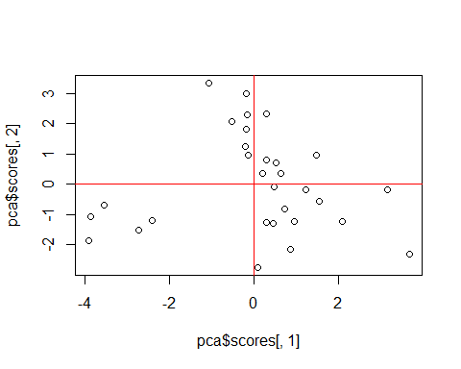

fviz_eig(pca)

